**Portfolio Construction for Minerals in Lithium-ion Batteries**

1. **Battery Selection**

* LFP: LFPs are an emerging battery technology that is slowly taking over the EV market. September [2022 saw a 31% market share, with production projected to surpass NMC by 2028, and due to LFP patents expiring in 2022](https://www.teslarati.com/tesla-byd-68-percent-all-lfp-batteries-deployed-q1-q3-2022-report/), we saw [LFPs attain a market share of around 40% in 2023](https://www.iea.org/reports/global-ev-outlook-2024/trends-in-electric-vehicle-batteries?trk=public_post_comment-text). Tesla, which previously used NCAs, switched to LFP for their new model Y.
* NMC-111: most generic NMC battery. Currently [NMCs occupy around 60% of the EV battery market](https://www.iea.org/reports/global-ev-outlook-2023/trends-in-batteries).
* NMC-811: popular choice among EVs for their low cobalt content, as cobalt is expensive
* NCA: used by Tesla in many of their models, including roadster, model S, and model 3.. More energy dense for more range in their EVs. [Only occupies 8% of the market](https://www.iea.org/reports/global-ev-outlook-2023/trends-in-batteries).
* LCO: used in almost all handheld electronic devices, such as smartphones, laptops, cameras, etc.

1. **Chemical Composition**

The composition of these four batteries are as follows:

* LFP: lithium, iron ore, and phosphate
* NMC: lithium, nickel, manganese, cobalt, and oxygen
* NCA: lithium, nickel, cobalt, aluminum, and oxygen
* LCO: lithium, cobalt, and oxygen

The exact percentages are found in the Python code. The chemical percentages for LFP was attained via a website, but the rest were calculated using stoichiometry (finding exact chemical formula, then using molar mass of individual elements to find what percentage of mass each mineral occupies). In this process, oxygen is also factored into the weight, but was not ignored as it should be accounted for when producing battery using raw materials from minerals.

1. **Data Collection**

Data for aluminum, cobalt, iron ore, lithium, manganese, and nickel was downloaded via the IMF (International Monetary Fund)’s [Primary Commodity Price System](https://data.imf.org/?sk=471dddf8-d8a7-499a-81ba-5b332c01f8b9&sid=1547558078595). Conveniently, all the prices were in USD per ton.

However, IMF lacked data on phosphate, which is a key component of LFP batteries. The source of phosphate in LFPs is [usually from reacting iron sulfate (iron ore) with phosphoric acid](https://cen.acs.org/energy/energy-storage-/Lithium-iron-phosphate-comes-to-America/101/i4#:~:text=Most%20factories%20in%20China%20produce,that%20forms%20the%20conductive%20coating.), which is usually [derived from phosphate rocks](https://www.vaisala.com/en/chemical-industry-solutions/chemicals-allied-products/wet-process-phosphoric-acid-production). As such, it makes sense to track the price of phosphorus in LFPs through the price of phosphate rocks, which was downloaded from [IndexMundi’s Commodity Prices](https://www.indexmundi.com/commodities/?commodity=rock-phosphate).

Prior to using these sources, data was obtained from [FRED (Federal Research Economic Data)](https://fred.stlouisfed.org/), but there was the notable exception of lithium prices. IMF had prices for battery-grade lithium, which is what we needed.

Below is a visualization of the price changes for the minerals used for batteries:

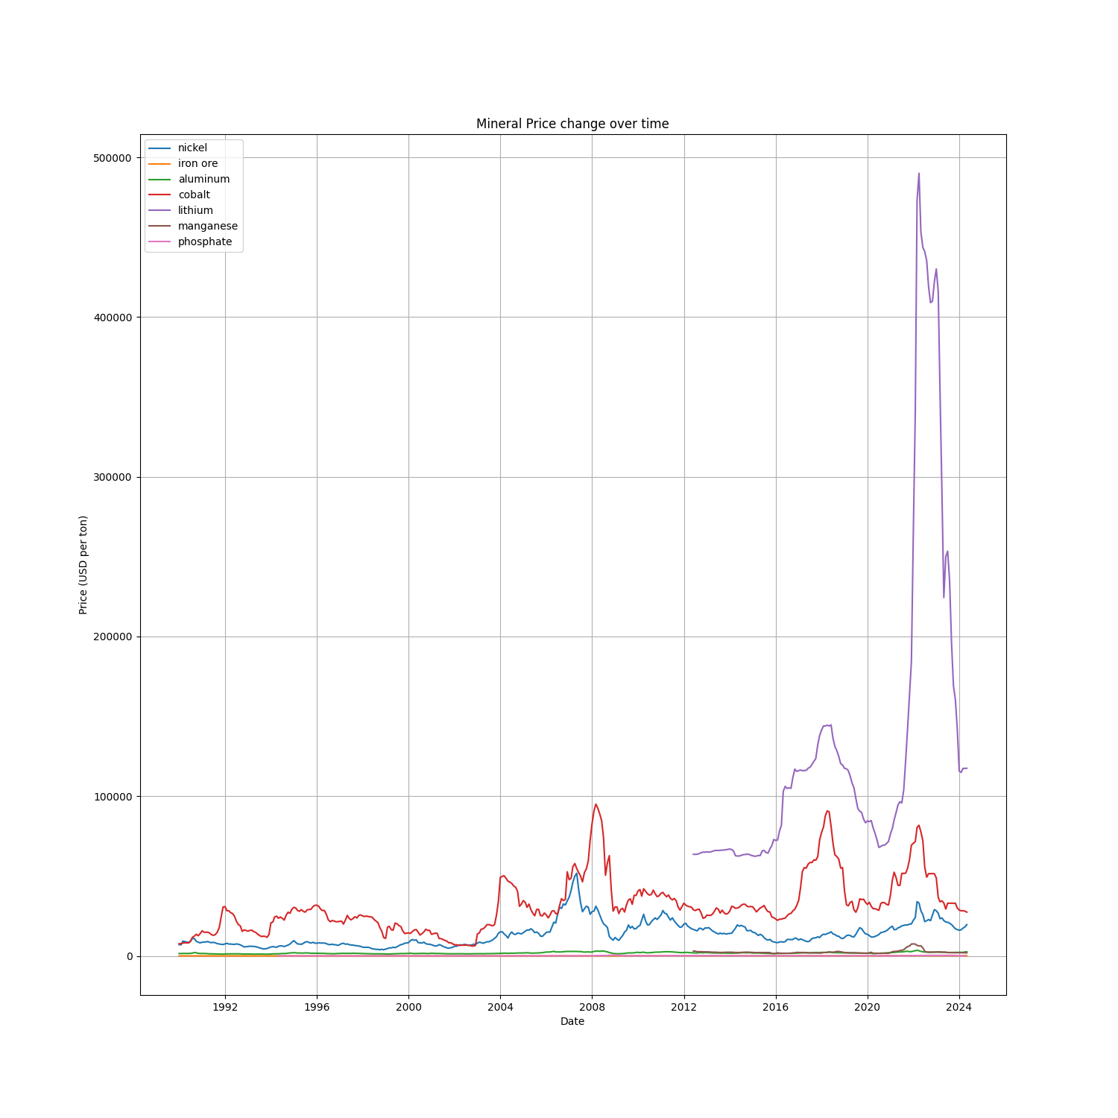

1. **Data cleaning**

For the portfolios for the various batteries, only dates with all data for the specific minerals that compose a battery are used. Since all the batteries use lithium, only data from late 2012 to current 2024 are used. As a result, all data prior to 2012 is omitted. However, a future endeavor could be made to attain battery-grade lithium prices prior to 2012, or use machine learning methods to attain prior data.

After this filter was applied, the fractional weights calculated earlier were applied to scale the prices according to the weight of each mineral in the battery.

1. **Visualisations**

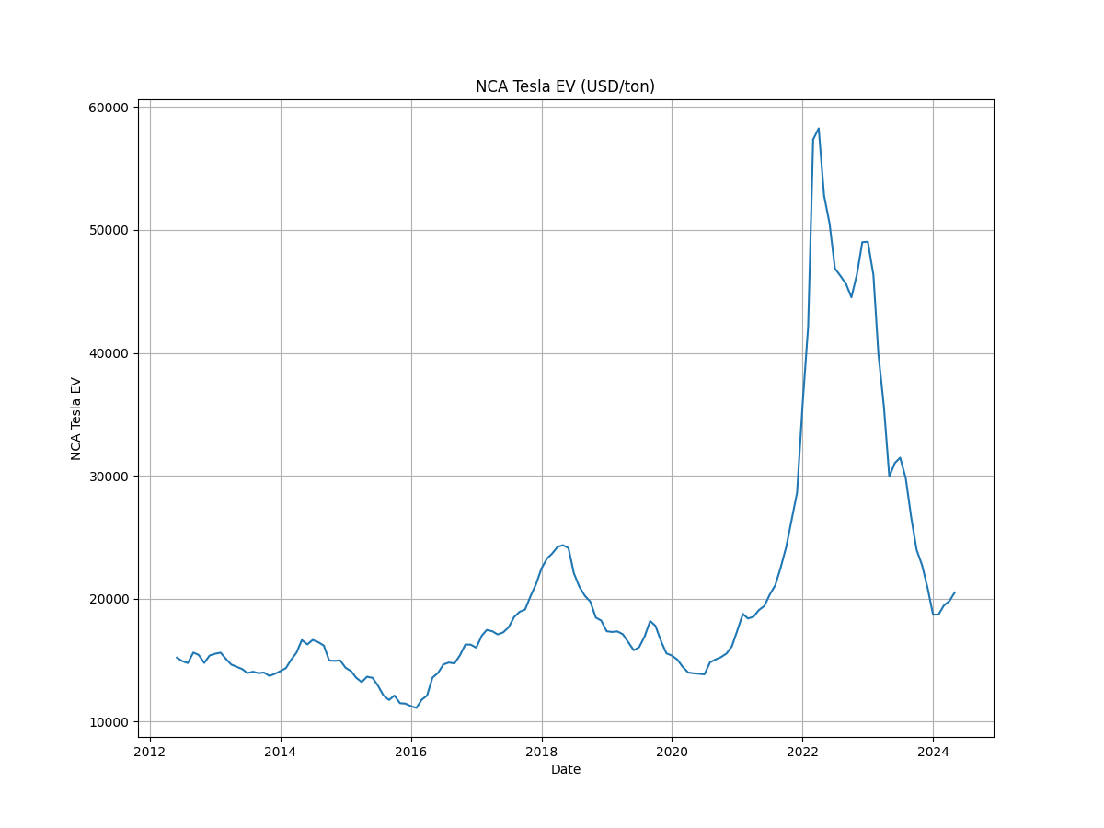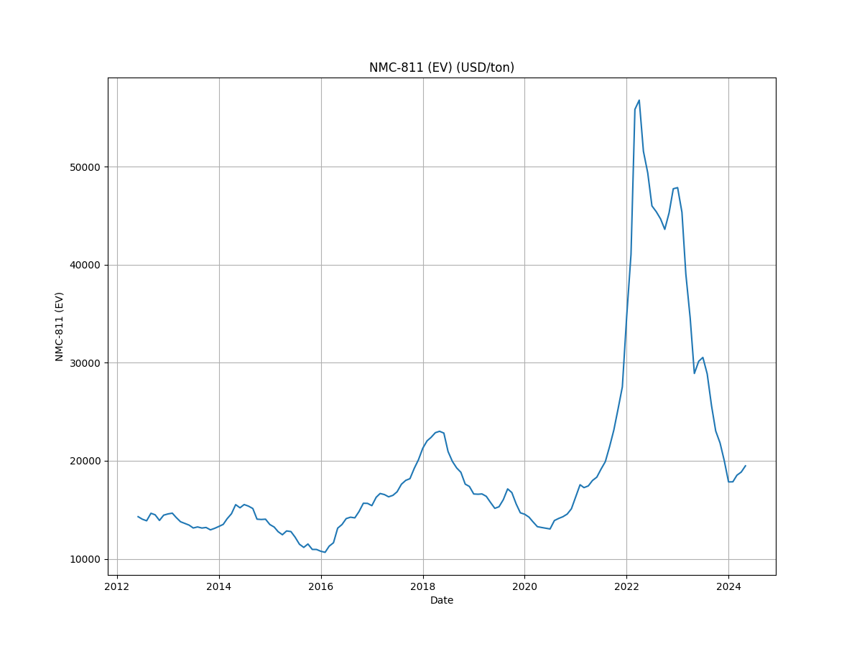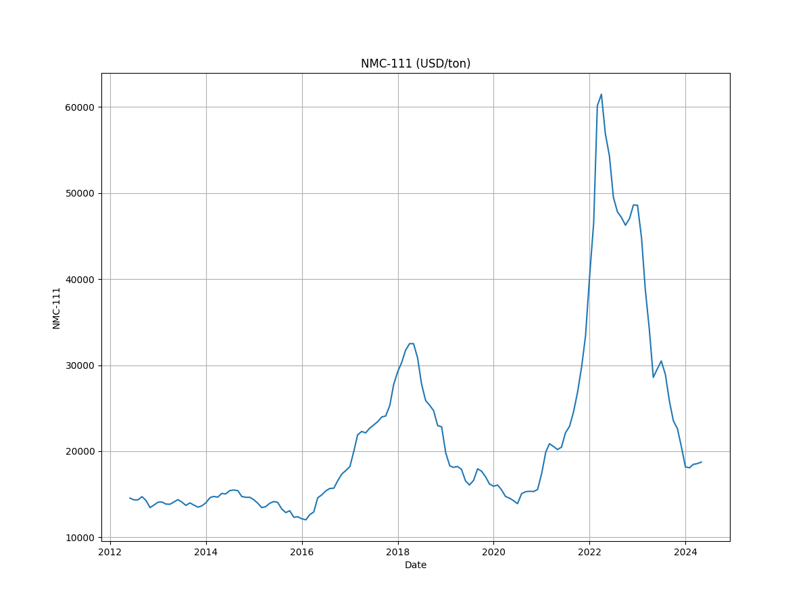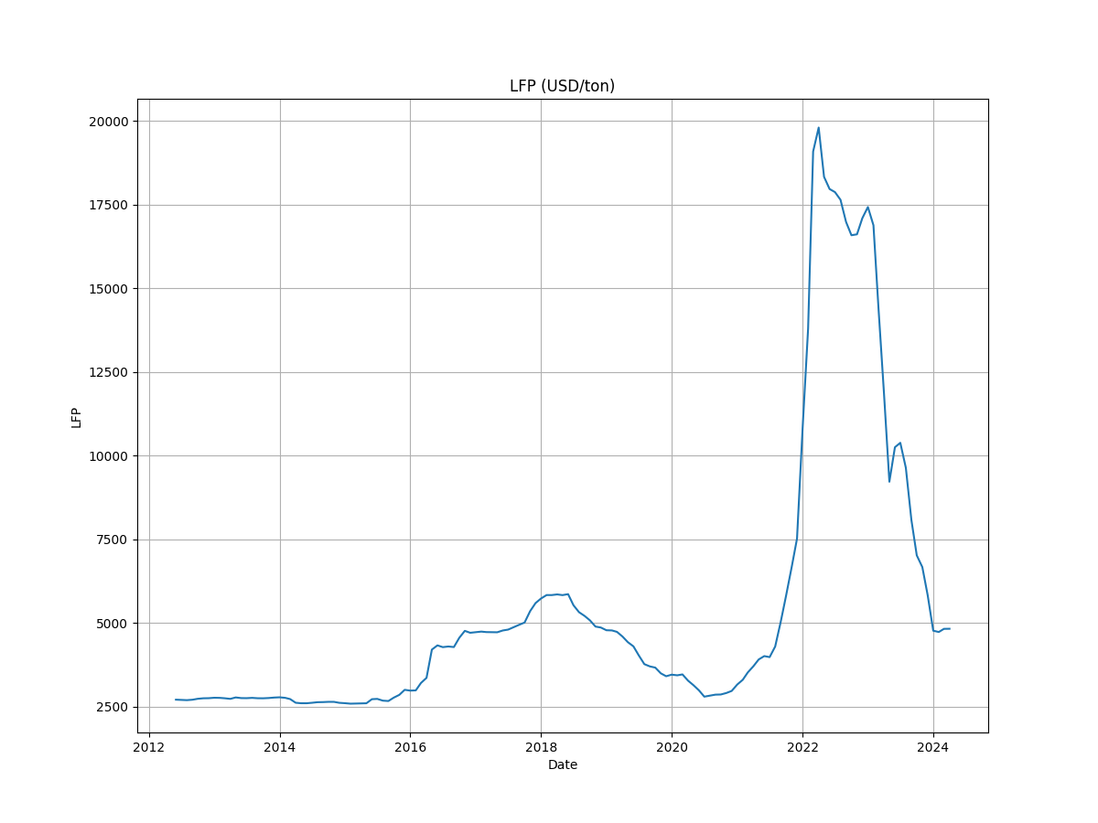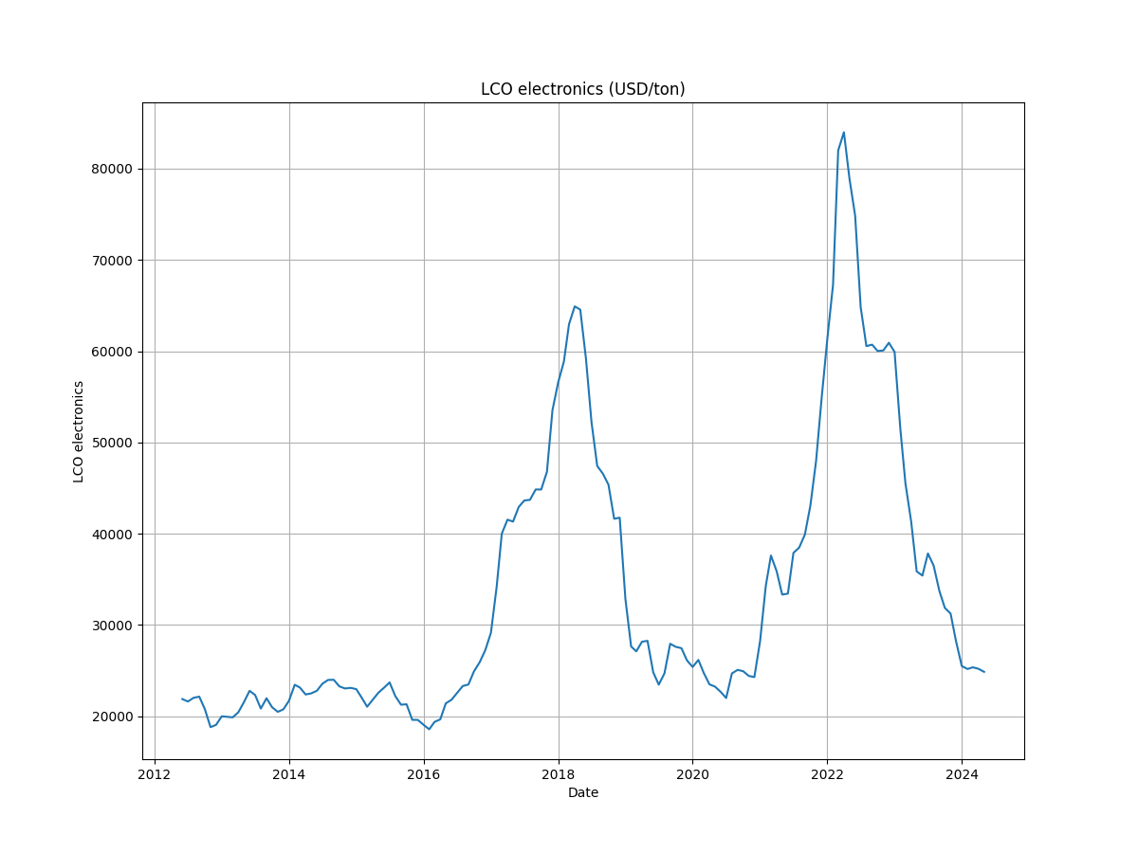

1. **Findings (Price trend analysis):**

* LFP: The price of LFP showed a gradual increase from 2020 until around 2024, while it spiked significantly, reaching its peak near 2022.
* NMC-111: it fluctuated moderately from the early 2012 until around 2021, where a significant upward trend began.
* NMC-811: Similar to NMC-111, NMC-811 experienced the same fluctuation but showed a more pronounced increase starting around 2021. The price peaked around 2022 to 2023, and then decreased sharply, but remained above earlier levels.
* NCA: The price showed a significant increase around 2021, and then peaking sharply in 2022, after the peak, the price decreased substantially around 2023, but remained above the earlier levels.
* LCO: The price exhibited a moderate fluctuation with a significant rise starting 2021, peaking 2022. And then a post-decline was observed, bringing price down but still higher than the earlier levels.

Commodity prices spiked in 2022 due to a number of factors, including [the increase in global demand for commodities, energy prices increase, and Russia’s invasion of Ukraine](https://www.usbank.com/investing/financial-perspectives/market-news/commodity-prices-impact-on-the-market.html#:~:text=Are%20commodity%20prices%20rising%3F,increased%20inflation%20during%20that%20period.).

1. **Recommendation:**

Based on the analysis of price trends for different battery types and their respective minerals, the following recommendations are made:

* Given the significant price volatility observed in NMC and NCA batteries. It is suggested to diversity sourcing strategies. This could involve securing long-term contracts with multiple suppliers or investing in mining operations to stabilize supply and reduce dependency on market fluctuation.
* LFP has shown a more stable price trend compared to other types, and are becoming increasingly popular in the EV market. Investing in LFP technology could provide a cost-effective and reliable alternative to NMC and NCA batteries.
* The significant price spikes observed in 2022 can be attributed to global events such as the increase in global demand for commodities, and Russia’s invasion of Ukraine. It is suggested that procurement strategies should be timely adjusted according to market dynamics.
* Considering stockpiling of key battery materials when prices are relatively low can hedge against future price spikes and protect against sudden market disruption.
* In addition, It is better to control material costs by joining ventures with raw material producers and battery manufacturers.

Further quantitative analysis needs to be done to explain the price spikes in the mineral prices in order to explain the price spikes in the battery prices.